Northern Lakes Dental & Implant Center

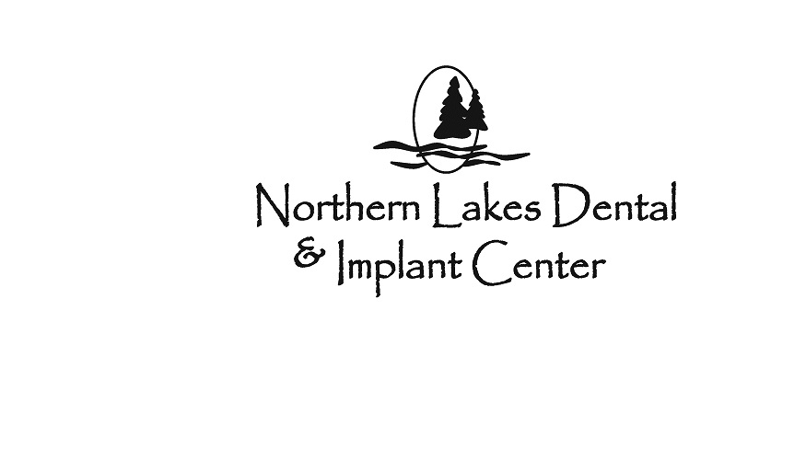

1108 Western Ave.

Fergus Falls, MN 56572

northernlakesdental@prtel.com

Phone: 218-736-4000

Fax: 218-736-0766

**Dental Records Release Form**

Patient Name: __________________________________________________  
Date of Birth: _______________ Phone Number: ______________________

Previous Dental Clinic: ____________________________________________

Address: _______________________________________________________

City / State / Zip: ________________________________________________

Phone Number: ______________________________

I hereby give you permission to release any and all of my dental records to Northern Lakes Dental & Implant Center.

________________________________________ ____________________________

Patient Signature (guardian if a minor) Date

**Dental Clinic use only.**

Please forward any of the following information that you have:

Last Exam: _____________ Last Prophy: __________

Last Bitewing: ___________ Last Pano: __________

Last FMX: _______________